1 Terminal Velocity Simulation

1. Model Settings

For the pressure and temperature, they are not involved directly in the model. But they affect simulation by changing viscosity, density, and surface tension coefficients.

|  |  |
| --- | --- |
| Pressure (Pa) | 80000 |
| Temperature (°C) | 15 |
| Water Density (kg/m³) | 999.13 |
| Air Density (kg/m³) | 0.96718 |
| Water Kinematic Viscosity (㎡/s) | 1.1384e-6 |
| Air Kinematic Viscosity (㎡/s) | 1.48e-5 |
| Surface Tension Coefficient (N/m) | 0.7315 |

1. Results

|  |  |  |  |  |  |  |
| --- | --- | --- | --- | --- | --- | --- |
| Diameter (mm) | Terminal Velocity (m/s) | Time to Terminal Velocity (s) | Distance to Terminal Velocity (m) | Horizontal Velocity Oscillation Period (s) | Vertical Velocity Oscillation Period (s) | b/a ratio |
| 0.1 | ≈0 | NA | NA | NA | NA | 0.98-1.02 |
| 0.5 | 0.25 | 0.15 | 0.07 | 0.003 | 0.05 | 1.00-1.03 |
| 1 | 2.9 | 0.25 | 0.55 | 0.15 | 0.1 | 0.5-1.3 |
| 1.5 | 2.8 | 0.4 | 0.95 | 0.1 | 0.1 | 0.5-1.4 |
| 2 | 4.6 | 1.5 | 5.42 | 0.04 | 0.04 | 0.74-0.79 |
| 2.5 | 4.8 | 1.5 | 4.66 | 0.05 | 0.025 | 0.705-0.728 |
| 3 | 5.0 | 1.5 | 3.92 | 0.15 | 0.1 | 0.645-0.668 |
| 3.5 | 5.0 | 1.5 | 4.95 | 0.1 | 0.1 | 0.677-0.706 |
| 4 | 5.1 | 1 | 1.80 | 0.15 | 0.15 | 0.63-0.68 |

2 Breakups Identification

1. Neck/Filament Breakup

Neck/Filament Breakup occurs when there’s a large collision angle.

Coalescence happens when the collision momentum is small. (the last two figures)

     

1. Disk breakup

Disk breakup happens when the two raindrop diameters are similar, or momentum is large enough to deform shape instantly.

In 3D, there will be extension on z axis. The cross-section taken by camera should be a “disk”.

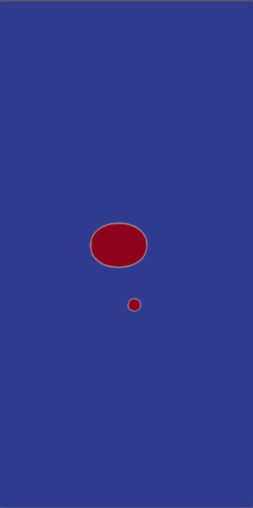 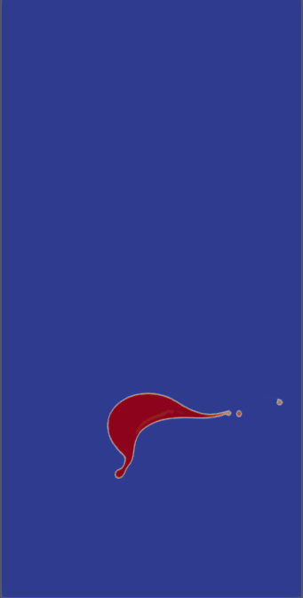 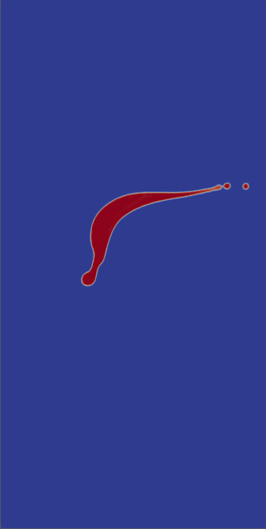  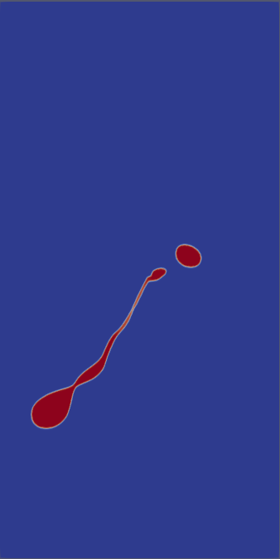 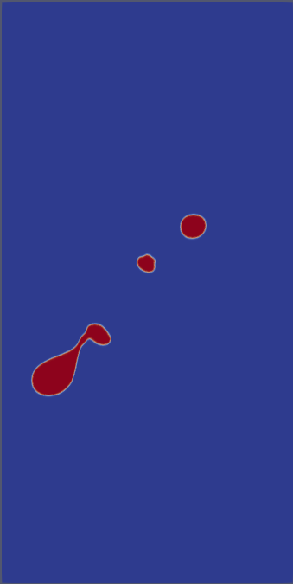

1. Crown Breakup

Crown Breakup occurs when a small drop hits a larger one with medium momentum (not strong enough to deform shapes but not weak enough to form coalescence. This case might be a crown breakup if increase resolution. The shape looks quite similar with crown photo. I will test more velocities.

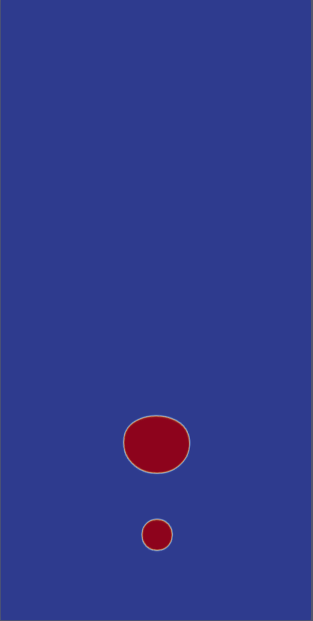    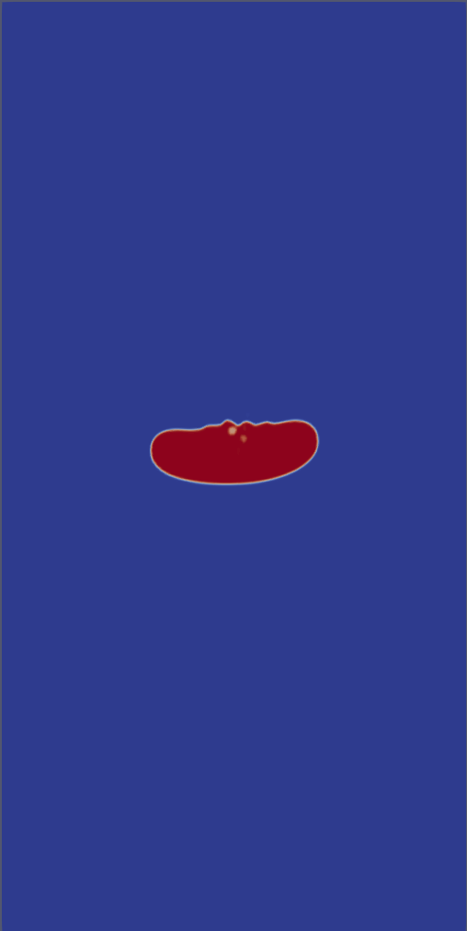 

1. Sheet Breakup

Top drop has lower velocity, then it increases velocity then catch up with the bottom raindrop. This case is close to sheet type breakup.

     